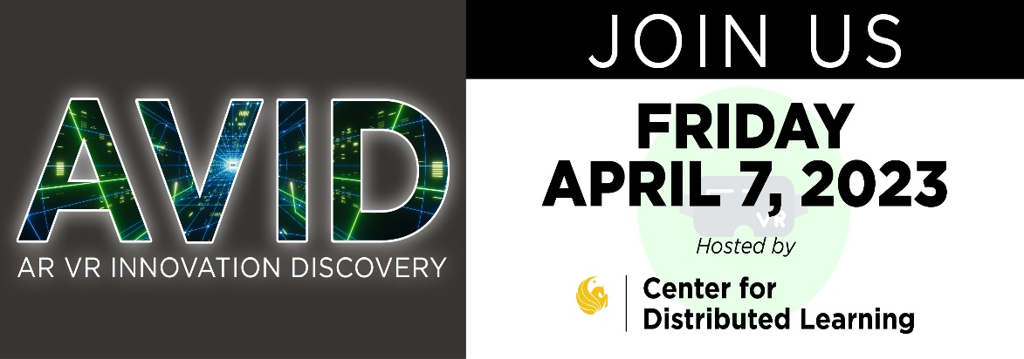

Venue: Faculty Multimedia Center (FMC), located in Classroom building 1 (Room 202)
Date and time: Friday, April 07 from 1:30-3:00pm

Time | Agenda | Description
Leading up to 1:30pm | Pre-event Start Up | Attendees arrival and sign in.
1:30 – 1:35 | Welcome  Dylan Yonts  Faculty Multimedia Center Manager  Rocco Fazzalari  Project Assistant, Pegasus Innovation Lab  Eric Fabra  Multimedia Support Specialist, Pegasus Innovation Lab  Savannah Graves  IT Client Support Specialist, Faculty Multimedia Center | Welcome.  About the event, as well as a quick overview from Dylan about the FMC.
1:40 – 1:55 | Discovery Session 1  A UCF-developed VR Simulation Testbed for Research on VR Training Effectiveness  Dr. Florian Jentsch  Department Chair of Psychology | The presentation covers the development of FlightPET, a simulation testbed that supports research on modern training practices in the air carrier industry. FlightPET is available in both VR and conventional desktop mediums and is designed to identify the best combinations of training technologies and approaches for specific tasks.  The presentation discusses the integration of human factors in the instructional systems design process for developing VR simulation systems for flightcrew training. It also includes lessons learned for VR development, such as mitigating visual occlusion and kinetosis, and future development concepts like dashboards, intelligent agents, and self-regulated learning supports.
1:55 – 2:10 | Discovery Session 2  Holoportation and Blended Learning Immersive Technology: A New Frontier in Interdisciplinary Healthcare  Dr. Bari Hoffman  Associate Dean of Clinical Affairs | The global pandemic highlighted the urgency for providing novel approaches to healthcare and healthcare education as the scope and complexities of patient care evolves rapidly. This presentation will demonstrate the utilization of two new technologies, i.e., holoportation, to unlock geographic constraints uniting ‘patients’ and future healthcare providers through a holographic environment along with a Blended Learning Interactive Simulation Suite (BLISS). The immersion in whole-patient health has the potential to prepare healthcare providers who express true humanistic care and emerge with advanced cultural competence as this technology expands our reach into diverse groups of previously underserved populations.  In this session, participants will learn about new holoportation technology and how it is being implemented into healthcare education. Advantages and lessons learned from implementation will be outlined. Integration with other emerging technology across topics related to patient safety, lived experiences, symptoms profile, social determinants of health, empathy, and overall care will be addressed. Discussion will focus on various ways the technology is currently or planning to be used across a variety of healthcare disciplines highlighting potential growth opportunities and novel care pathways.
2:10 – 2:25 | Discovery Session 3  Measuring the Effectiveness of Immersive Virtual Learning Environments on Learning?  Dr. Roger Azevedo  Professor and Director, Laboratory for the Study of Metacognition and Advanced Learning Technologies | There is a widespread assumption by researchers, educators, and technologists that immersive virtual learning environments are effective for learning. But are they? How do we know? What is the evidence? How do we measure effectiveness? Besides the hype, this talk will discuss the significant challenges with immersive virtual learning environments and why they may not always impact learners.  In this task, I will present how to measure the effectiveness of immersive virtual learning environments by using real-time methodologies (e.g., concurrent verbalizations, expression of emotions, eye movements, physiological arousal, screen recordings of learners-system interactions, gestures) to understand how cognitive, affective, metacognitive, motivational, and social processes impact learning. I will use examples from our research in STEM and biomedical sciences with K-12 learners and healthcare professionals to exemplify the measurement issues associated with immersive virtual reality environments.
2:25 – 2:40 | Discovery Session 4  How is Intellectual Property impacting AR/VR in an academic setting?  John Miner  Assistant Director, Physical Sciences  Office of Technology Transfer | This discussion will focus on the role that Intellectual Property and specifically academic Technology Transfer can have in the burgeoning AR/VR/MR scene. There will be a short primer on the basics of intellectual property, how IP is used in the AR/VR spaces, and what UCF has experienced and focused on in the last decade or more of experience protecting and commercializing technology in this area. This presentation will be followed by a lively question and answer period where you can discuss your particular concerns.  John Miner is an award winning Technology Transfer professional with over 20 years of academic Technology Transfer experience focusing on the Physical Sciences including: Photonics/Optics, Simulation, AR/VR/MR, Software, and Education. He is a long time member of the Association of University Technology Managers (AUTM) and is the Chair of the Metrics and Surveys Committee.
2:40- 2:55 | FMC Informational Session  XR @ the FMC  Faculty Multimedia Center members | FMC Presentation on extended reality that intends to demonstrate what the Faculty Multimedia Center has for faculty to utilize. How can these tools be used in and outside the classroom?
2:55 and onward | Closure  Dylan Yonts  Faculty Multimedia Center Manager | The FMC is open until 5, please walk around and interact with some of our VR and AR stations that we have set up in partnership with our presenters.  Thank you for coming!

